 |  | 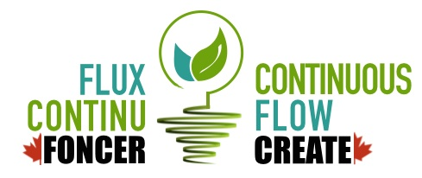
GRADUATE SCHOLARSHIP IN CONTINOUS FLOW SCIENCE
CREATE APPLICATION FORM
Student Name:
E-mail Address:
Status in Canada:
Cumulative GPA:
Degree To Be Obtained:
Research Supervisor:
Home University:
Department:
Other Financial Support:
Project Title:
Abstract [1/2 page]

